

Robotic Process Automation

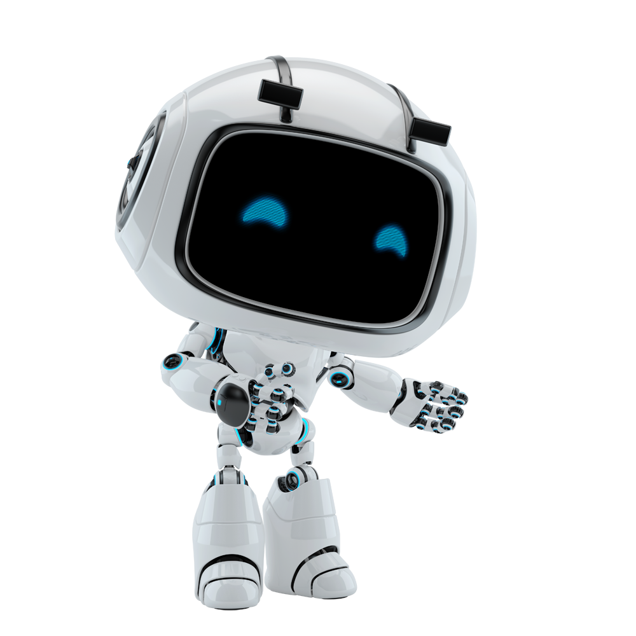

UIPath Automation

Solution design document

Revision History

|  |  |  |  |  |  |
| --- | --- | --- | --- | --- | --- |
| Date | Version | Description | Author | Reviewed by | Approved by |
| 23 Dec 2016 | 1.1 | Created Document | Tejus Venkatesh | Florica Tudor |  |
|  |  |  |  |  |  |
|  |  |  |  |  |  |

|  |  |  |  |
| --- | --- | --- | --- |
| **Division** | **Roles** | Responsibilities | Name/Company |
| Provider | RPA Business Analyst | Feasibility Study & Solution Design |  |
| RPA Project Lead | Lead project implementation |  |
| RPA Programmers | Develop workflow & scripts |  |
| Customer / Client | Subject Matter Expert | Provide info along with exceptions |  |
| Process Owner | Approve documented process |  |
| Project Manager | Manage resources and timelines |  |
| Robot Operations | Robot Monitor | Credentials and health of Robot |  |
| Change Management Owner | Assess change technically & from business perspective |  |
| Business Process Owner | Manage RPA project in live Environment |  |

Project Stakeholders list

Table of Contents

1. Introduction 5

1.1 Purpose of this document 5

1.2 Objectives 5

2. AS IS Process Description 6

2.1 Overview 6

2.2 High Level process diagram 6

2.3 Detailed Process mapp 6

2.4 AS-IS Process Steps 6

2.5. Exceptions 7

2.6 Operating Environment 7

3. Solution Overview 8

3.1 To Be Process Overview 8

3.2 Scope 8

3.3. Assumptions 9

3.4 Key challenges 9

3.5 To Be Process Steps 9

3.6 Technical Solution 11

3.6.1 Robot Deployment Overview 11

3.6.2. Error mapping 11

3.6.3 Reporting 11

3.6.4. Workflow and scripts 12

4. Security Management 13

4.1 Data Security assumptions 13

4.2 Credential Management 13

5. Testing 14

5.1 Alpha testing 14

5.2 User Acceptance Test 14

6. Service Level Agreement – SLA 15

7. Prerequisites for development 16

8. Potential Benefits 17

9. Annexure 18

9.1 Sign Off Email copy 18

9.2 Add Workflow files, scripts etc 18

9.3 Add Error Mapping 18

9.4 Report samples, dashboards 18

9.5 List of test cases 18

# 1. Introduction

## 1.1 Purpose of this document

Text text

Text text

## 1.2 Objectives

Text text

Text text

# 2. AS IS Process Description

## 2.1 Overview

General information about the process (include here process data that we capture on the RPA process diagnosis document).

## 2.2 High Level process diagram

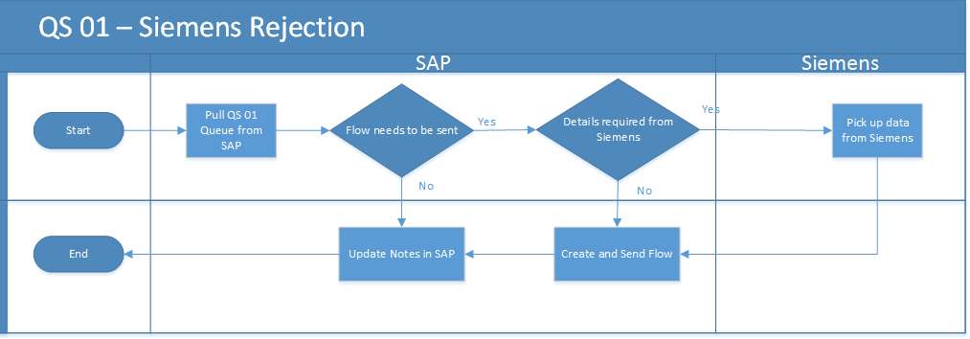

## 2.3 Detailed Process map

Detailed process map to be added here, with input/output flow at each stage. We can logically divide the process into stages if required (for better readability).

## 2.4 AS-IS Process Steps

Complete and concrete process steps at keystroke level or clicks to be defined with screenshots. (If there are any data restrictions, mask important data like Policy Number, Customer ID etc).

## 2.5. Exceptions

Below are the exceptions captured during the process study.

## 2.6 Operating Environment

* Operating System of Local Environment: Windows 7
* IE version – IE 10
* Citrix Type: Citrix Desktop (Windows 7 OS) with IE 9
* Clipboard access between local desktop and Citrix is disabled

2.6.1 Application details

|  |  |  |
| --- | --- | --- |
| Application | Use | Type  (running environment) |
| **SAP** | To populate rejection queue and to action on each item | Citrix ERP |
| **One Form** | To send key or card | Citrix Windows (MS Access) |
| **Siemens** | To check active status of customer | Citrix Web based |

* SAP times out after 2 hours of inactivity
* Siemens times out after 20 mins of inactivity
* No credentials required or there is any time out for OneForm

# 3. Solution Overview

## 3.1 To Be Process Overview

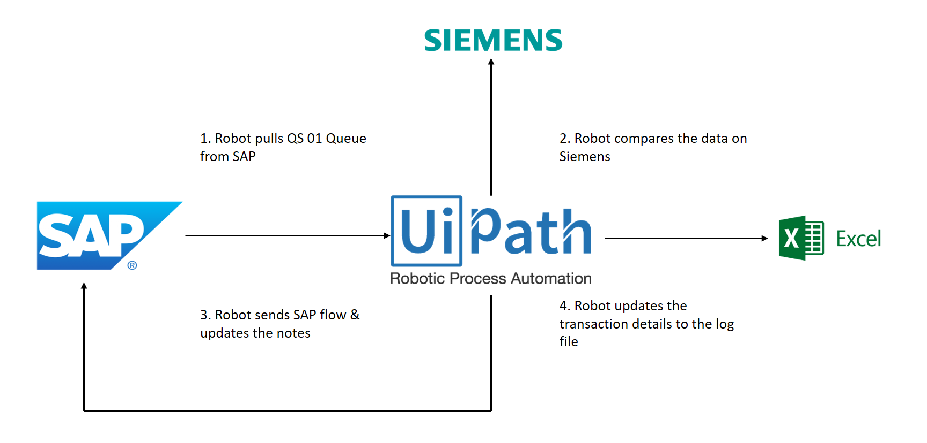

Automation type: Back Office Robot

No human intervention – Jobs scheduled by Orchestrator.

## 3.2 Scope

This section defines the scope of the project

### 3.2.1 In Scope

* All the activities which are in scope
* To be defined here

### 3.2.2 Out of Scope

* All activities and exception out of scope
* To be defined here

## 3.3. Assumptions

All activities which have been performed to tweak the as is process to enable higher rates of automation on the process.

* Process Assumption
* Input Data assumption
* Number or types of input to be received

## 3.4 Key challenges

**Challenges**

List all the various challenges and constraints that we foresee during process study: For Example – Accuracy of data captured from scanned PDF

**Mitigation Plan**

Mitigation plan or workaround to be followed for each of the challenge listed above.

## 3.5 To Be Process Steps

To be process flow will be defined here with detailed flow chart and steps.

Exceptions, logging, notification mechanisms should be part of it.

(diagram depicted on the next page)

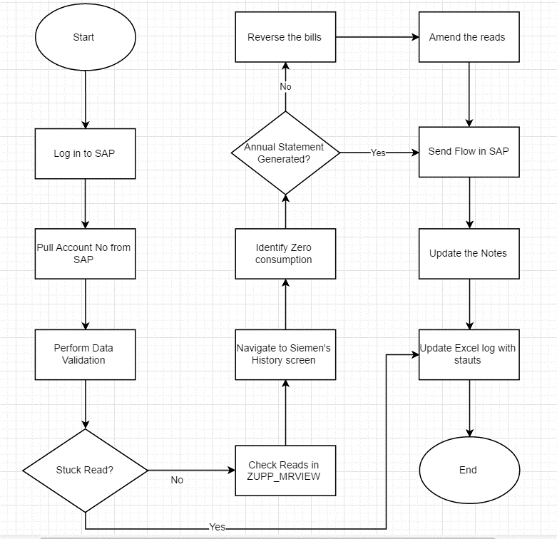

## 3.6 Technical Solution

## 3.6.1 Robot Deployment Overview

|  |  |
| --- | --- |
| Type of robot | How many robots are used |
| **Front office or Back Office** | **8** |
| Robot Communication  Using Queues, Shared Folders | Schedule of Robot  Monday-Friday 08:00-17:00 CET |
| Targeted productivity per robot (volume)  100 per day or week or month | Targeted Average Handling Time  8 min per transaction |

### P.S: We can think of some (better) template to update above info.

## 3.6.2. Error mapping

A comprehensive list of all the errors or warnings or notification sent by Robot should be consolidated here with the description and action to be taken. From the beginning of development

RPA programmers must identify these points and code accordingly. Attach the Error Mapping sheet in Annexure

## 3.6.3 Reporting

The details and format of the logging available in the workflow must be specified here. (Whether it is creating local log reports or Orchestrator logs).

The format should be as specified by the business users. Sample logs and dashboard screenshots to be attached in the Annexure

## 3.6.4. Workflow and scripts

A brief of each workflow and the sequence in which are executed should be described here. (Like in Technical Design Document).

All the workflows, scripts and Project folder to be attached at the Annexure.

# 4. Security Management

## 4.1 Data Security assumptions

Details here ……..

## 4.2 Credential Management

Describe the password policy and who is responsible for managing credentials and updates.

|  |  |  |  |
| --- | --- | --- | --- |
| Name of Robot | IP | Responsible  person | Password policy |
| Avani | 10.2.3.4 | Adam | Update every 60 days |
| Jadoo | 245.21.3.5 | Ricky | Update every 90 days |
| Krissh | 12.23.45.6 | Starc | Non expiring password |

# 5. Testing

Below are the various stages in testing. Update each item with Testing plan.

|  |  |  |  |  |  |  |  |
| --- | --- | --- | --- | --- | --- | --- | --- |
| Testing | | Owner | Start date | End date | # of test cases | % of Success | Status |
| **Alpha** | RPA Project Lead | |  |  |  |  |  |
| **User Acceptance Testing** | Process SME | |  |  |  |  |  |
| **Regression Testing** | Process Owner | |  |  |  |  |  |
| **Security Testing** | Client IT / Info Sec Team | |  |  |  |  |  |

## 5.1 Alpha testing

Alpha and Beta Testing: Alpha testing is the testing done by RPA developers and RPA project lead at site after the development.

## 5.2 User Acceptance Test

UAT (User Acceptance testing): It is performed by the end users or process SMEs. List of all the test cases to be tested must be documented by Business team (Attach the test case list in Annexure)

Note: Regression & Security tests depends on organization. Please add any specific testing principles here.

Also agree on the UAT support, GO Live support period with the Customers/ Business.

# 6. Service Level Agreement – SLA

Text text text….

# 7. Prerequisites for development

* Development or testing environment will be provided for development
* Production and Development/testing environment are exact replica of each other
* Dedicated system and application access are given to developers with adequate access
* Dedicated IDs are provided in Production for Robot Ids after UAT with adequate access and it is replica of the access provided to developers during development
* Operations team creates test cases and provides test data for development and testing

# 8. Potential Benefits

|  |  |  |
| --- | --- | --- |
| Volume | AS IS | Post Automation target |
| Volumes | 160 | 160 |
| AHT* | 4 | 5 |
| FTEs | 2 | 0 |
| # of productive hours | 16 | 13 |

*AHT = Average Handling time

AHT Calculation = Total records / hour

AHT = (60 mins /RPH) 4

RPH= Robots Records Processed per Hour

Note: To handle current volumes we would need 1 Back office license to execute the automation.

# 9. Annexure

## 9.1 Sign Off Email copy

text

## 9.2 Add Workflow files, scripts etc

text

## 9.3 Add Error Mapping

text

## 9.4 Report samples, dashboards

text

## 9.5 List of test cases

text